PT LAPI GANESHA UTAMA
in collaboration with IoT Lab & Physics Lab, Institut Teknologi Bandung (ITB)

Document No.: LGU/GLD/INSTR-MAN/2026-001 Classification: Working Draft — Confidential

Gas Leak Detector (GLD) Instruction Manual
IoT-based multi-gas leak detection node — GLD Tahap 2 program, PT Pertamina Patra Niaga
Document Control
Document title | GLD Instruction Manual
Document number | LGU/GLD/INSTR-MAN/2026-001
Revision | 0.5 (Working Draft)
Date | 22 September 2026
Prepared by | LAPI Ganesha Utama (LGU), with IoT Lab & Physics Lab ITB
Object of this manual | Node Sensor (GLD) only — Cluster Head and Gateway are separate devices, referenced only for system context
Related certification item | IECEx/ATEX checklist §2.6.g — Usage and installation instructions

Scope and status of this document. This is a working draft, modeled structurally on a published instruction manual for a comparable certified diffusion-type gas detector, and populated with GLD's own confirmed design data wherever available. It is not an approved or finalized manual, and GLD is not yet ATEX/IECEx certified — see Section 15, Certification Status. Fields not yet established are explicitly marked Pending confirmation rather than estimated. This document must be reviewed and approved by LGU engineering and, where applicable, by Pertamina RU IV before being treated as an operational instruction.

Revision History
Revision | Date | Description
0.1 | 22 Sep 2026 | Initial working draft, structured from the reference manual of a comparable certified gas detector (New Cosmos KD-12/KD-12R) and populated with GLD's confirmed design data.
0.2 | 22 Sep 2026 | Added safety-warning, operating-mode (Inference/Dataset/Nulling), and commissioning-equipment content drafted 18 Sep 2026, cross-referenced with §2.6.g of the certification document.
0.3 | 22 Sep 2026 | Added dimensioned CAD reference drawings (Section 4.1: “GLD ATEX CASE v3” contingency enclosure design and BP18-1Z candidate junction-box component; Section 5.1: L-bracket/U-bolt mounting assembly), for the party managing the ATEX/IECEx certification submission.
0.4 | 22 Sep 2026 | Power cable confirmed as 2-conductor, labeled L+/L− (positive/negative of the 24 VDC supply), each conductor ≈0.75 mm diameter (Sections 4, 6, 13). Cable gland/thread size remains pending.
0.5 | 22 Sep 2026 | Enclosure material grade confirmed as ADC12 die-cast aluminum + stainless steel (Sections 4, 13), extrapolated from the casing manufacturer's die-cast product line; status raised from Partially available to Final with this caveat noted.

Table of Contents
1. Introduction 4
2. Safety Precautions 4
3. Package Contents 5
4. External Dimensions and Nomenclature 6
4.1 Enclosure Reference Drawings 6
5. Installation 8
5.1 Mounting Method 8
5.2 Mounting Location and Height 10
6. Power Supply and Wiring 10
7. Communication and Network 11
8. Precautions Before Use 12
In Case of a Gas Leak Alarm 12
9. Gas Detection and Alarm Operation 12
9.1 Operating Modes 13
10. Status Indication and Fault Conditions 13
11. Maintenance and Inspection 13
11.1 Periodic Inspection 13
11.2 Sensor Response Verification 14
11.3 Sensor Replacement and Service Life 14
11.4 Commissioning and Test Equipment 14
12. Troubleshooting 15
13. Specifications 15
14. Certification Status 17
15. Warranty 17
16. Service Life 18
17. Glossary 18

1. Introduction
The GLD (Gas Leak Detector) is an IoT-based, multi-gas leak detection sensor node developed by LAPI Ganesha Utama (LGU) together with the IoT Lab and Physics Lab of Institut Teknologi Bandung (ITB), under the GLD Tahap 2 program for PT Pertamina Patra Niaga. GLD is intended to detect gas leakage at an early stage in refinery facilities and to report gas concentration status wirelessly to a central monitoring dashboard, helping to prevent incidents such as fires and explosions.
Unlike a conventional loop-powered gas detector with a local 4–20 mA analog output and an on-unit keypad/display, GLD is a wireless sensor node: it classifies gas conditions on-device and reports status over a LoRa mesh network (via a Cluster Head and Gateway) to a central server and dashboard. GLD has no physical keypad or digital concentration display; status is conveyed through a local visual/audible alarm module and remotely through the dashboard.
GLD currently classifies ambient air into three conditions on-device: Clean Air, LPG, and H₂ (hydrogen). It does not yet cover CO₂, Benzene, CO, or H₂S; expanding gas coverage is an active area of the program (see Section 13, Specifications).
GLD is not yet certified for use in ATEX/IECEx classified hazardous areas. Certification is in progress — see Section 14, Certification Status. Do not install GLD in a classified hazardous area until certification is complete and the equipment has been confirmed suitable for the applicable zone, gas group, and temperature class.

2. Safety Precautions
WARNING
• Do not install GLD in a classified (ATEX/IECEx) hazardous area until certification of the equipment for the applicable zone, gas group, and temperature class has been completed and confirmed. GLD's certification is currently in progress (Section 14).
• Any cable entry device and blanking element used with GLD in a hazardous area must be of a type of protection and certification suitable for the intended zone and correctly installed. GLD's own cable entry specification is currently Pending confirmation (Section 13); do not assume a specific cable gland is suitable without written confirmation.
• Do not disassemble the product or modify its enclosure, wiring, or firmware. Doing so may compromise any explosion-protection measures once certification is finalized, and will void any future certification coverage.
• Be sure to ground the unit in accordance with the site's electrical safety requirements to prevent electric shock.
• Only trained and authorized personnel may install, commission, operate, inspect, or maintain GLD.
• Isolate and verify the 24 VDC supply before opening the enclosure or changing wiring. Apply the site lockout/tagout (LOTO) procedure.
• Perform alarm tests with appropriate site controls and hearing protection where an audible alarm device is connected.
• Perform sensor nulling only in confirmed clean air, and accept the result only when all eight sensors report a complete 8/8 pass (see Section 9, Operating Modes); otherwise correct the cause and repeat.
• Remove the unit from service if there is visible damage, water ingress, an unresolved sensor fault, failed alarm proof, or a loss of protective-earth continuity.

CAUTION
• All work involving GLD — including installation, wiring, and mounting — must be carried out by suitably trained personnel in accordance with the applicable code of practice and site HSE procedures.
• Do not install GLD near sources of silicone sealant vapor or other substances known to poison metal-oxide gas sensors; this may permanently degrade sensor performance.
• Handle the sensor unit and enclosure with care. The gas-sensing elements are directly exposed to ambient air (not enclosed) and can be damaged by physical impact, dust ingress, or contact with liquids.
• Mounting to existing plant structures must not involve drilling or welding unless a different method has been separately approved in writing by the site (RU IV). See Section 5, Installation.
• Fasteners used for mounting must use a material and grade suitable for the site environment (anti-corrosion required); the specific fastener grade for GLD's bracket is currently Pending confirmation (Section 13).
• Do not create new cable entries, enlarge an entry, leave unused entries open, or substitute a general-purpose gland once a certified entry device is specified (Section 13).

NOTE
GLD's gas-sensing elements (metal-oxide type) are intentionally exposed to ambient air through the enclosure mesh, in the same manner as comparable diffusion-type gas detectors, in order to sense gas concentration. The ignition-protection status of this sensing aperture (e.g. whether a certified flame-arrestor element is required) is under evaluation as part of the ongoing ATEX/IECEx certification process and is not yet finalized.

3. Package Contents
The following items are expected to accompany each GLD unit at delivery. This list reflects the current project design and will be finalized alongside the certification and vendor handoff process.
Item | Status
GLD sensor node (main unit) | Confirmed
Mounting bracket set (L-bracket + U-bolt, 2″/DN50) | Confirmed — see Section 5
External LoRa/Wi-Fi antenna (SMA connector) | Confirmed
Power adapter (220 VAC/50 Hz → 24 VDC) or site-supplied 24 VDC feed | Partially confirmed — supply arrangement to be agreed with site (Section 6)
Cable gland(s) | Pending confirmation — specification not yet determined (Section 13)
Fasteners for bracket mounting | Pending confirmation — grade not yet determined (Section 13)
This Instruction Manual | Confirmed

4. External Dimensions and Nomenclature
Overall dimensions: 200 × 90 × 290 mm (L×W×H). Enclosure neck diameter Ø75 mm, probe/casing height 191.51 mm. Weight: ≈2 kg (project-confirmed value; not yet verified against a calibrated weighing record). Enclosure material: aluminum alloy (ADC12 die-cast grade) and stainless steel.
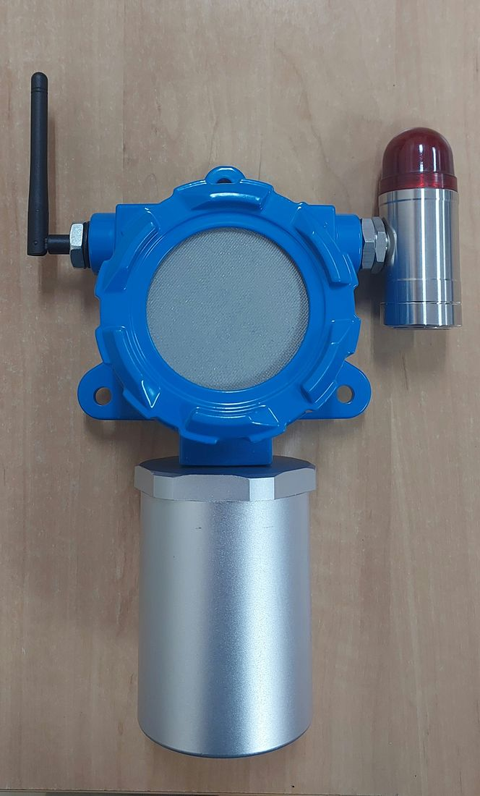
Front view — assembled unit: motherboard housing (blue), sensor mesh cover (silver, top), external antenna (left), local visual/audible alarm module (right).
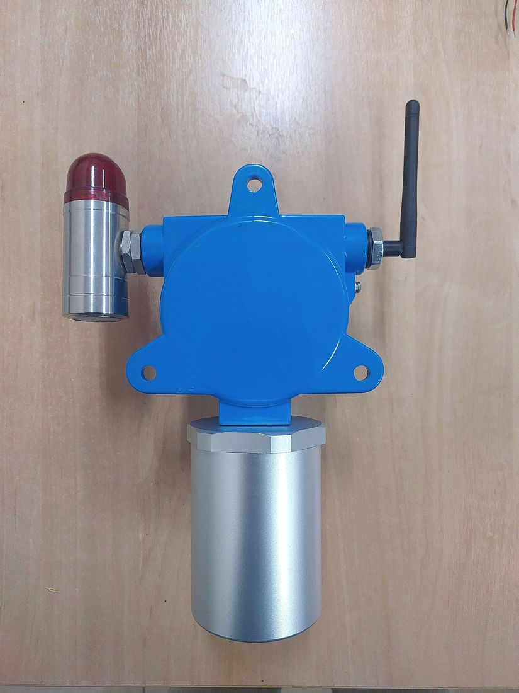
Rear view — mounting flange (4-hole pattern), matching the L-bracket/U-bolt mounting plate described in Section 5.

4.1 Enclosure Reference Drawings
The photographs above show the current physical prototype. The dimensioned CAD sheets below are engineering reference drawings, not confirmed final production drawings — see the caption on each for its status.
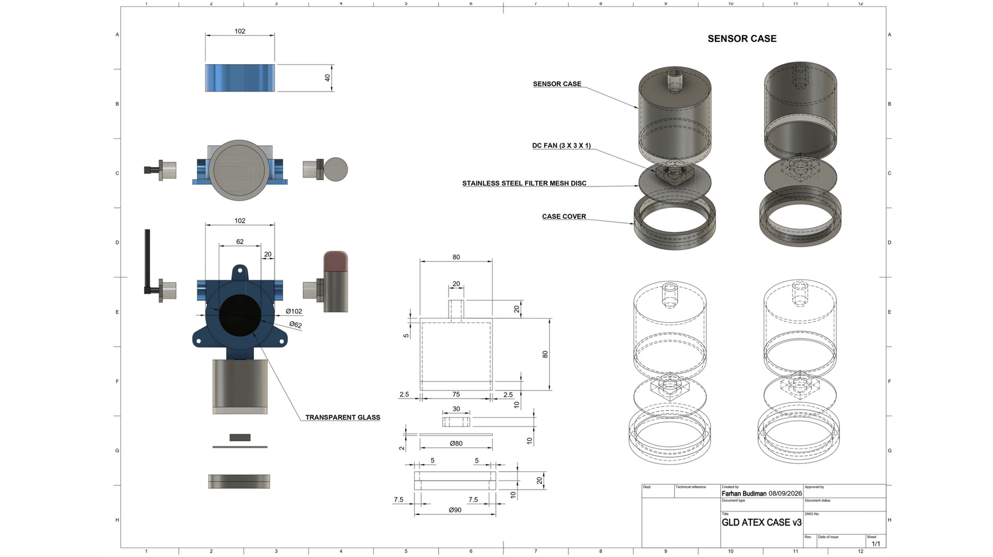
“GLD ATEX CASE v3” — dimensioned drawing sheet (Farhan Budiman, 8 Sep 2026). Shows an exploded assembly (Sensor Case, DC fan 3×3×1, stainless-steel filter mesh disc, case cover, transparent viewing window) with key dimensions (case body Ø102 mm outer / Ø62 mm sensor bore, 40 mm collar height, mounting base Ø80/Ø90 mm bolt circle). Status: internal contingency/alternate enclosure design, developed in parallel with the primary sourcing path (a commercially available CE/ATEX-marketed housing product line, Section 13) — it is not itself the confirmed production enclosure and is not yet independently verified against IEC 60079-0.
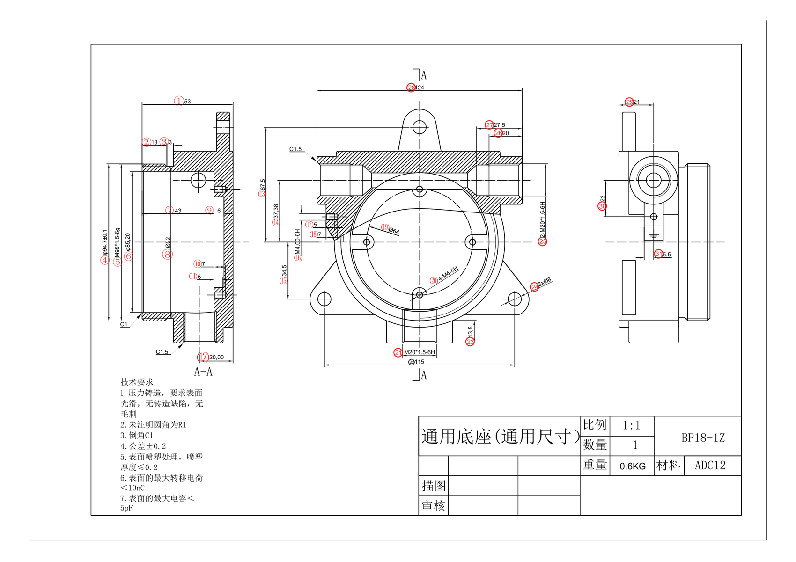
“Universal Base” BP18-1Z — supplier reference drawing (Chinese enclosure-component manufacturer, ADC12 die-cast aluminum alloy, 0.6 kg). Cable entry 2× M20×1.5-6H, mounting 3× Ø8 mm, overall ≈124×115×67.5 mm. Surface treatment specifies electrostatic-safety limits (charge transfer <10 nC, capacitance <5 pF) consistent with IEC 60079-0 coating requirements. Status: candidate junction-box/terminal sub-component under evaluation by the casing partner’s supply chain — its footprint does not match GLD’s main enclosure, and it is not yet confirmed as part of GLD’s design.
Component | Description
Sensor cover / mesh | Perforated cover over the 8-channel gas sensor array; sensing elements are directly exposed to ambient air (not enclosed).
Local alarm module | Cylindrical housing with red lens, mounted to one side of the enclosure; provides local visual (flashing) and audible alarm indication.
External antenna | External, omnidirectional, SMA male connector, 3 dBi gain, used for the LoRa radio link. On some units the 2.4 GHz Wi-Fi antenna remains inside the enclosure and must be relocated externally for optimal configuration-mode range.
Cable entry | Location for power and (where used) RS-485 wiring. Power cable is 2-conductor, labeled L+/L− (positive/negative of the 24 VDC supply), each conductor ≈0.75 mm diameter (Section 6). Thread size and certified cable gland requirement: Pending confirmation.
Mounting flange | 4-hole pattern on the rear of the enclosure, matched to the L-bracket mounting plate (Section 5).
Status indication | No on-unit digital display or keypad. Status is conveyed via the local alarm module and remotely via the dashboard; see Section 10.

5. Installation

5.1 Mounting Method
GLD is mounted to existing plant structures using an L-bracket and U-bolt clamp, without drilling or welding into the structure. This design follows the reference approach already used for corrosion-monitoring instrumentation at the refinery (Emerson-style bracket).
Parameter | Value | Status
Clamp type | U-bolt, 2″ / DN50 | Final
Target pipe / structure outer diameter | 60.3 mm | Final
U-bolt thread | M10 | Final
U-bolt inside width | 62–65 mm | Final
U-bolt inside height | 95–100 mm | Final
Thread length per leg | 40 mm recommended (35 mm minimum viable) | Final
Mounting plate | 250 × 250 mm | Final
Spacer (if bracket/structure is thicker) | 45–60 mm | Final
Mounting orientation | Confirmed suitable for horizontal handrail-type structures. Compatibility with a vertical pole has not yet been verified in writing. | Pending confirmation
Fastener size and grade | Not yet determined by the design team. Generic industry reference standards (not an official GLD spec): BS 3974 Part 2, DIN 3570/3567, ASME B18.31.2/ASTM A193 Gr.B7. | Pending confirmation

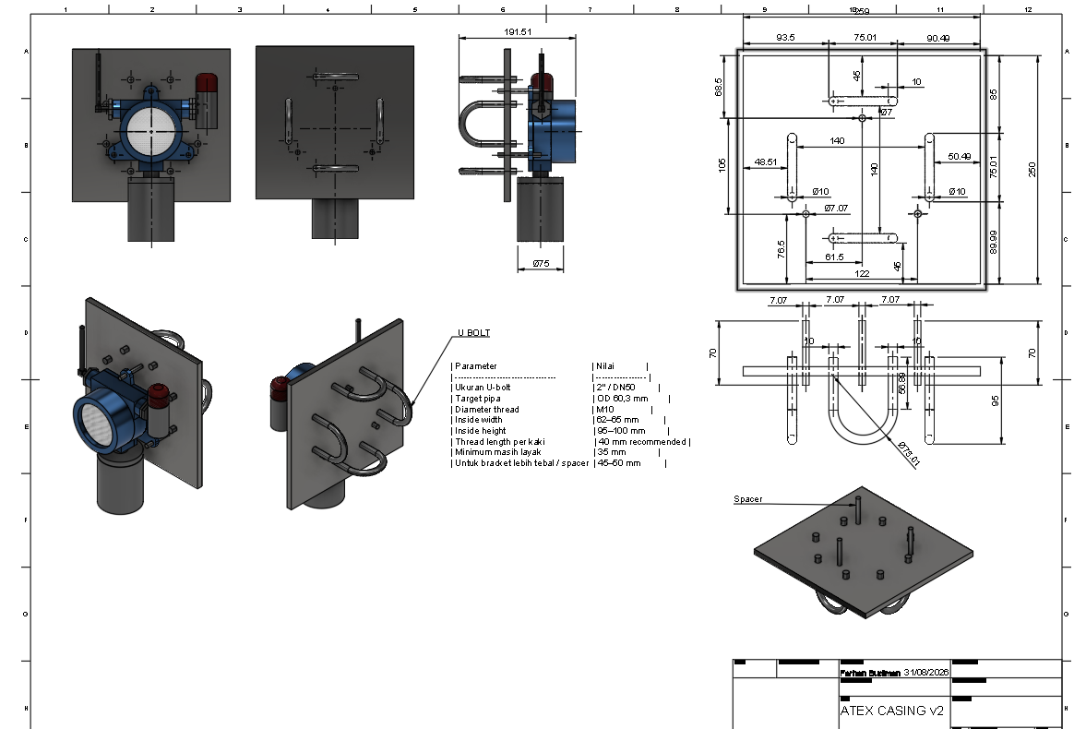
Enclosure envelope and L-bracket/U-bolt mounting assembly — dimensioned drawing sheet (drafted 31 Aug 2026, from a STEP solid model). Orthographic and isometric views showing the enclosure neck (Ø75 mm), overall probe height (191.51 mm), mounting plate (250×250 mm with toleranced hole pattern), and the U-bolt parameters listed in the table above (2″/DN50, M10 thread). This is the same drawing referenced in the IECEx/ATEX certification document, Section 2.6.a.
CAUTION
• Do not drill or weld the existing structure. Use only the L-bracket/U-bolt method described above unless an alternative method has been separately approved in writing by RU IV.
• PVC must not be used in any housing or bracket component. All fasteners and brackets must be of an anti-corrosion material suitable for the site environment.
• Confirm the mounting orientation (horizontal vs. vertical structure) with the installing party before fabrication, as vertical-pole compatibility is not yet written-verified.

5.2 Mounting Location and Height
GLD is designed to detect multiple gases with different vapor densities (for example, LPG is heavier than air, while H₂ is lighter than air). Unlike a single-gas detector, a single mounting height cannot simultaneously be optimal for every gas GLD may be asked to detect. The mounting height and location for each installation point should therefore be selected by site engineering based on the specific target gas(es) and hazard assessment for that location, rather than a single fixed rule.
General siting guidance (adapted from established gas-detector practice, to be applied per site hazard assessment):
Relative gas density | General guidance
Heavier than air (e.g., LPG) | Mount low, close to grade or process equipment where the gas is expected to accumulate.
Similar to air (e.g., carbon monoxide) | Mount at approximately breathing height, considering local air movement.
Lighter than air (e.g., hydrogen) | Mount high, near the ceiling or upper structure where the gas is expected to accumulate.

Do not install GLD in locations where: the ambient temperature exceeds the specified operating range (Section 13); condensation regularly occurs; water is directly sprayed; the atmosphere is corrosive beyond the specified rating; or interfering hydrocarbon gases other than the intended target gas are continuously present. Provide sufficient clearance around the enclosure for cable access and maintenance.

6. Power Supply and Wiring
Parameter | Value | Status
Input voltage | 24 VDC (continuous) | Final
Source adapter (if AC-fed) | 220 VAC / 50 Hz input → 24 VDC output | Final
Internal voltage rails | 5 VDC (sensor/heater circuitry), 3.3 VDC (ESP32-S3 logic) | Partially available — per-rail current not yet documented separately
Measured power consumption | 7.995 W @ 24 VDC (≈0.33 A) | Final (production configuration)
Cable/PSU sizing margin | ≥1 A per unit | Final (sizing margin only; actual draw is well below this)
Power connector type | Not yet determined | Pending confirmation
Cable type and gauge | 2-conductor DC power cable, labeled L+/L− (positive/negative of the 24 VDC supply), each conductor ≈0.75 mm wire diameter | Partially available — conductor count/diameter confirmed; overall cable outer diameter, insulation rating, and gauge-standard designation (e.g. AWG/mm²) not yet documented
Electrical protection | Resettable PPTC fuses (F1/F2), TVS/ESD suppression diodes, Schottky diodes on power rails | Partially available (component-level evidence)

WARNING
• Turn off the power supply before opening the enclosure or connecting/disconnecting wiring. An energized circuit may become a source of ignition in a hazardous area.
• Ground the unit in accordance with the site's electrical safety requirements before energizing.

A separate Li-ion 18650 battery pathway exists as a parallel R&D track and is not part of the standard production power configuration described above. The Ex/cell safety certification of this battery (e.g., against IEC 62133 / UN38.3) has not yet been verified and is out of scope for a standard installation using the 24 VDC supply above.

7. Communication and Network
GLD does not have a wired 4–20 mA analog output or a dry-contact relay output. Its telemetry and alarm status are transmitted wirelessly.
Parameter | Value
Radio module | E22-900MM22S (LoRa)
Operating frequency | 920 MHz (regional ISM band)
Transmit power | 17 dBm (firmware-configured); module maximum 22 dBm
Modulation parameters | 125 kHz bandwidth / SF7 / coding rate 4/5
Link encryption | AES-128-GCM
Antenna | External, omnidirectional, SMA male, 3 dBi
Reporting interval | Configurable, default 10 seconds; alarm events are transmitted immediately
Network topology | GLD → Cluster Head (star / multi-hop mesh) → Gateway → MQTT broker → server/dashboard
Wi-Fi | Local configuration only (enabled/disabled by command). Not used for telemetry — LoRa remains the sole telemetry backbone at all times.
RS-485 / Modbus RTU interface | Read-only slave, 9600 bit/s, 8N1, Unit ID 1 (THVD1410DR transceiver). Provides 8 read-only registers: device status word, classification result, confidence, battery voltage, power source, external power indicator, LoRa transmission counter, and node ID. Intended for integration with an external controller or acquisition system; not used to control the product.

NOTE
If GLD is required to interface with a separate indicator, alarm panel, or building management system, integration should be planned through the RS-485/Modbus register set above or through the dashboard/MQTT layer — not through an analog loop or dry contact, neither of which GLD provides.

8. Precautions Before Use
CAUTION
Before energizing GLD or any connected device, recheck that all wiring connections are correct, particularly the power supply polarity and any RS-485 bus connections.

In Case of a Gas Leak Alarm
WARNING
• Follow your site's emergency response procedures immediately upon a gas leak alarm.
• If the leak occurs indoors, ventilate the area in accordance with site procedure.
• Do not operate electrical switches in or near the affected area; sparks may cause ignition.
• Confirm safety with a calibrated portable gas detector before re-entering the affected area, in accordance with site procedure.

9. Gas Detection and Alarm Operation
GLD uses eight metal-oxide gas sensor channels (MQ-2, MQ-3B, MQ-4, MQ-5, MQ-6, MQ-7B, MQ-8, MQ-135), with sensing elements directly exposed to ambient air. Signals are digitized by a 24-bit multi-channel ADC (ADS1256IDBR, 30,000 SPS) and sampled at a 500 ms scan interval. An on-device AI classifier running on the ESP32-S3 processor evaluates the sensor pattern and outputs one of three classes: Clean Air, LPG, or H₂. A dedicated SHT40 sensor provides auxiliary temperature/humidity telemetry.
Current alarm logic: an alarm is raised when the classified condition is not Clean Air and the classification confidence is at least 30%.
On alarm, two parallel channels are activated: (1) the local visual/audible alarm module on the unit itself, and (2) a push notification transmitted over the LoRa network to the central dashboard, targeting a cycle time of approximately 10 seconds. Under normal (non-alarm) conditions, the system uses a longer polling interval (approximately 90 seconds) to conserve network bandwidth.
VALIDATION STATUS
The push-alarm pathway has been successfully validated on a campus mesh test network. Validation of this pathway at an actual refinery (RU) installation has not yet been performed.

NOTE
The current 3-class model does not yet cover CO₂, Benzene, CO, or H₂S. Expansion of gas coverage depends on the availability of reference gas samples for on-site training (see Section 11, Maintenance).

9.1 Operating Modes
GLD firmware distinguishes three operating modes:
Mode | Purpose | Use restriction
Inference | Normal gas-class inference and alarm operation | Production operating mode after commissioning
Dataset | Engineering / data-collection activity | Not a substitute for approved detection operation
Nulling | Sensor baseline / calibration activity | Clean air only; perform under an approved procedure; require a complete 8/8 result (see Section 11.2)

CAUTION
Do not change firmware, model files, alarm thresholds, or calibration parameters from the field without controlled approval and a documented rollback path. Before each operating period, check power, enclosure condition, diagnostic status, communication status, and the absence of active faults. Treat an alarm as a real process-safety event until the site response procedure establishes otherwise.

10. Status Indication and Fault Conditions
GLD has no on-unit digital display or numeric fault-code readout comparable to a conventional stand-alone gas detector. Status and fault information are available through two channels:
- Local alarm module — visual (flashing) and audible indication of an active gas alarm.
- Remote dashboard / RS-485 status register — device status word, classification result, confidence, battery voltage, power source, and external power indicator, available via the central dashboard or by polling the RS-485/Modbus register set described in Section 7.
A dedicated on-unit fault/error code table, of the kind found in conventional stand-alone gas detectors, has not been defined for GLD. Fault diagnosis currently relies on the dashboard and/or the RS-485 status word; see Section 12, Troubleshooting, for the fault conditions that are understood at this time.

11. Maintenance and Inspection

11.1 Periodic Inspection
Item | What to check
Sensing element / mesh | Clogging, corrosion, or physical damage to the sensor mesh cover.
Enclosure and mounting hardware | Corrosion of the enclosure, mounting bracket, U-bolt, and fasteners; security of the mounting.
Antenna and cabling | Integrity of the antenna, its connector, and the power/RS-485 cable entry.
Local alarm module | Visual/audible operation, physical condition of the lens and housing.
Site conditions around the unit | Confirm nothing obstructs the diffusion of gas to the sensing elements.

A formal inspection frequency (e.g., monthly/quarterly/annual, as used by comparable certified detectors) has not yet been established for GLD and should be defined by LGU together with Pertamina RU IV as part of the operational handover.

11.2 Sensor Response Verification
GLD's sensor response is verified using the project's portable gas test chamber and reference gas samples, following the project's on-site chamber-based methodology: the chamber is brought to the deployment location, a controlled gas sample is introduced, and the sensor/classifier response is checked and, where needed, the on-device model is retrained using the locally captured data. This differs from the zero/span calibration procedure used by conventional analog gas detectors, since GLD does not have an analog output to calibrate; instead, its AI classifier is verified and retrained against reference gas exposure.
Before returning a unit to Inference mode after verification or maintenance, run Nulling mode (Section 9.1) in confirmed clean air. Accept the result only when all eight sensors report a complete 8/8 pass; otherwise correct the cause and repeat before placing the unit back in service.

11.3 Sensor Replacement and Service Life
The metal-oxide (MQ-series) sensing elements used in GLD are consumable components with a finite service life, as is typical for this sensor technology. A specific recommended replacement interval for GLD's sensors has not yet been established and should not be assumed to match the service life figures published for other sensor technologies (e.g., electrochemical or NDIR sensors used in other detector models). See Section 16, Service Life.

11.4 Commissioning and Test Equipment
The following equipment is used to commission and functionally verify a GLD unit before it is placed in service:
Equipment | Purpose
Regulated 24 VDC power supply | Provides a stable 24 VDC supply during commissioning and functional testing.
Digital multimeter | Measures actual voltage, verifies polarity and continuity, and supports grounding/bonding verification.
Calibrated gas source / gas test kit | Provides the required gas types to verify correct sensor response.
Gas test chamber | Provides a controlled gas-exposure environment for reproducible test conditions (see Section 11.2).
Alarm load / relay simulator | Verifies that the alarm output and connected electrical load operate correctly.
LoRa peer / gateway | Verifies that data transmitted by GLD is successfully received by the intended system.
Laptop and approved software | Reviews diagnostic information, configuration, logging, and firmware identification; stores commissioning and test evidence.
Calibrated torque screwdriver | Ensures glands, terminals, enclosure fasteners, and grounding connections are tightened to approved torque values (Section 13).

12. Troubleshooting
Symptom | Possible cause | Suggested action
Unit does not report telemetry to the dashboard | Power not connected/incorrect wiring; LoRa link to Cluster Head not established; Cluster Head or Gateway offline | Check the 24 VDC supply and wiring; confirm the Cluster Head and Gateway are powered and within range; check dashboard connectivity status.
Local alarm module does not activate during a known alarm condition | Alarm module wiring/connector fault; module damage | Check the alarm module cable/connector; inspect the module for physical damage.
RS-485/Modbus master does not receive a response | Bus wiring fault; incorrect baud rate/parity; incorrect Unit ID | Confirm 9600 bps, 8N1, Unit ID 1, and correct A/B/GND wiring.
Classification appears incorrect or inconsistent | Sensor mesh contaminated or degraded; interfering hydrocarbon gas present; model not trained for the gas present | Inspect and clean the sensor mesh; verify the ambient environment; confirm the gas present is within the model's current 3-class coverage (Section 9).

If a fault condition is not covered above, or does not resolve after the suggested action, contact LGU technical support.

13. Specifications
Parameter | Value | Status
Sampling method | Diffusion type; sensing elements directly exposed to ambient air | Final
Gas sensors | MQ-2, MQ-3B, MQ-4, MQ-5, MQ-6, MQ-7B, MQ-8, MQ-135 (8 channels) | Final
Auxiliary sensor | SHT40 temperature/humidity (I2C) | Final
Signal acquisition | ADS1256IDBR, 24-bit, 30,000 SPS; 500 ms sensor scan interval | Final
Processing unit | ESP32-S3-WROOM-1U-N16R8 | Final
Detection / classification | On-device AI classifier, 3 classes: Clean Air, LPG, H₂. Does not yet cover CO₂, Benzene, CO, H₂S. | Final (current coverage)
Alarm logic | Alarm when classified condition ≠ Clean Air and confidence ≥ 30% | Final
Alarm indication | Local visual/audible module; LoRa push notification to dashboard (≈10 s target cycle) | Final (design); field validation at RU pending
Radio | LoRa, E22-900MM22S, 920 MHz, 17 dBm (fw), 125 kHz/SF7/CR4-5, AES-128-GCM | Final
Antenna | External, omnidirectional, SMA male, 3 dBi | Final
Auxiliary digital interface | RS-485/Modbus RTU, read-only, 9600 8N1, Unit ID 1 | Final
Analog output / dry contact | Not provided | Final (confirmed absent)
Power supply | 24 VDC continuous (from 220 VAC/50 Hz adapter or site 24 VDC feed) | Final
Power consumption | 7.995 W @ 24 VDC (≈0.33 A), production configuration | Final
Dimensions (L×W×H) | 200 × 90 × 290 mm | Final
Weight | ≈2 kg | Final (project-confirmed, not yet calibration-verified)
Enclosure material | Aluminum alloy (ADC12 die-cast) + stainless steel | Final — grade confirmed by extrapolation from the casing manufacturer's die-cast product line (Section 4.1); the main enclosure drawing itself does not carry its own material callout
Mounting | L-bracket + U-bolt 2″/DN50, non-invasive (no drilling/welding) | Final
Mounting orientation (vertical pole) | Not yet verified in writing | Pending confirmation
Fastener size/grade | Not yet determined | Pending confirmation
IP (ingress protection) rating | Not yet tested/determined | Pending confirmation
Power cable | 2-conductor, labeled L+/L− (positive/negative of the 24 VDC supply), each conductor ≈0.75 mm diameter | Partially available — conductor count/diameter confirmed; overall cable OD/insulation not yet documented
Cable entry / gland specification | Not yet determined | Pending confirmation
Operating temperature range | −40°C to +85°C (ambient) | Final (project-confirmed; not yet calibration/test-verified — see note below)
Operating humidity range | Not yet determined | Pending confirmation

NOTE ON OPERATING TEMPERATURE RANGE
The −40°C to +85°C figure above is a project-confirmed value corresponding to a typical extended-industrial electronics component rating. For reference, a comparable certified diffusion-type gas detector (New Cosmos KD-12/KD-12R) specifies a narrower field ambient operating range of −10°C to 50°C (RH 10–90%), which is more representative of actual refinery ambient conditions. Whether −40°C/+85°C is intended as GLD's true field deployment target, or is a component rating rather than a field specification, should be confirmed before this value is relied upon in a certification submission.

14. Certification Status
IMPORTANT
GLD is not yet ATEX/IECEx certified. The classification parameters below are the applicant's proposal for the purpose of the ongoing certification process; they are recorded here as a request, not as a granted or agreed classification. Do not represent GLD as certified, or as suitable for a specific hazardous-area zone, until a certificate has been issued.

Parameter | Requested / target value | Status
Equipment category / group | Category 2G, Group II | Requested — subject to ExCB assessment
Zone | Zone 1 | Internal recommendation — pending ExCB confirmation
Gas group | IIC | Internal recommendation, not an ExCB decision
Temperature class | T4 (≤135°C) | Target — verification outstanding (no hot-spot measurement performed yet)
Type of protection | Ex d, Ex e, or Ex i — under evaluation | Open
Standards to be applied | IEC 60079-0, plus the standard corresponding to the type of protection once selected | Dependent on the item above
Certification route | IECEx Certificate of Conformity and/or ATEX EU-type examination | To be confirmed with the ExCB
Nameplate / marking | Cannot be finalized until the above parameters are confirmed by the ExCB | Not yet available

The full technical submission supporting this certification effort is maintained separately in the project's IECEx/ATEX Technical Datasheet. This Instruction Manual is intended to satisfy the "usage and installation instructions" item of that submission once reviewed and approved.

15. Warranty
A formal warranty period and terms for GLD have not yet been established. Warranty terms will be defined by LGU as part of the commercial agreement with Pertamina and are not addressed by this technical manual.

16. Service Life
An overall design service life and a specific gas-sensor replacement interval have not yet been established for GLD. As with any metal-oxide gas sensor, sensing performance is expected to degrade over time and with exposure to high-concentration or contaminating gases; the sensing elements should be treated as consumable components requiring periodic verification (Section 11) and eventual replacement, on an interval to be defined once field experience is available.

17. Glossary
Term | Meaning
GLD | Gas Leak Detector — the sensor node described in this manual.
Cluster Head (CH) | An intermediate LoRa node that relays telemetry from one or more GLD units toward the Gateway, and can provide mesh routing between Cluster Heads.
Gateway | The device that bridges the LoRa mesh network to the MQTT broker and, from there, to the central server/dashboard.
Diffusion type | A gas detection method that relies on the natural diffusion of gas to the sensing element, rather than forced sampling.
Hazardous area | An area where an explosive gas atmosphere may be present, requiring appropriately certified equipment.
Zone | A classification of a hazardous area based on the likelihood and duration of an explosive atmosphere being present (e.g., Zone 0, 1, 2).
Gas group | A classification (e.g., IIA, IIB, IIC) of equipment suitability based on the ignition characteristics of the gases present.
Temperature class | A classification (T1–T6) of the maximum surface temperature that equipment may reach, to avoid igniting a surrounding explosive atmosphere.
LEL | Lower Explosive Limit — the lowest concentration of a flammable gas that will ignite when mixed with air.
RSSI | Received Signal Strength Indicator — used by Cluster Heads to select the best available parent link.

This document is a working draft, structured from the instruction manual of a comparable certified diffusion-type gas detector (New Cosmos KD-12/KD-12R) and populated with GLD's own confirmed design data. It is not yet an approved operational manual, and GLD is not yet ATEX/IECEx certified. Fields marked “Pending confirmation” must not be relied upon for procurement, installation, or certification purposes without further verification.

